5.2 Polar Worksheet

- A polar point has the coordinates. Find and fully simplify the Cartesian coordinates of this point.

$$θ$$
$$\left(8,\frac{5π}{6}\right)$$
$$y$$
$$x$$
$$r$$

- A Cartesian point has the coordinates . Find a polar coordinate representation for this point that has a positive value for r and another representation that has a negative value for r.

$$θ$$
$$\sqrt{75}$$
$$5$$
$$r$$

for some integer k.

Therefore we can create the possible following polar representations of the point (Note: there are infinitely many representations)

- Convert to rectangular coordinates.

$$θ$$
$$\left(6,\frac{π}{3}\right)$$
$$y$$
$$x$$
$$6$$

The rectangular coordinates of the point are:

- Convert to polar coordinates.

$$θ$$
$$\left(2, -2\right)$$
$$-2$$

$$2$$
$$r$$

Some possible polar coordinates of the point are:

- Convert to rectangular coordinates.

This point lies on an axis, so the conversion is simple.

$$\left(4, 3π\right)$$

The rectangular coordinates of the point are:

- Convert to at least 3 different points in polar coordinates.

$$\left(0,3\right)$$
This point lies on an axis, so the conversion is simple.

Some possible polar coordinates of the point are:

- Convert to rectangular coordinates.

$$θ$$
$$(-4,-\frac{π}{4})$$
$$y$$
$$x$$
$$r$$
The rectangular coordinates of the point are:

- Convert to polar coordinates.

$$θ$$
$$\left(-1, -\sqrt{3}\right)$$
$$-1$$

$$-\sqrt{3}$$
$$r$$
Note that since is in quadrant III and must return an angle in quadrant IV.

Some possible polar coordinates of the point are:

- Sketch a graph of the continuous polar curve whose points satisfy the following criteria.
- As increases from 0 to , r decreases from 4 to 2.
- As increases from to , r decreases from 2 to 0.
- As increases from to , r decreases from 0 to -1.
- As increases from to , r decreases from -1 to -3.

- Sketch a graph of the continuous polar curve whose points satisfy the following criteria.
- As increases from 0 to , r increases from 1 to 3.
- As increases from to , r decreases from 3 to 1.
- As increases from to , r increases from 1 to 3.
- As increases from to , r decreases from 3 to 1.
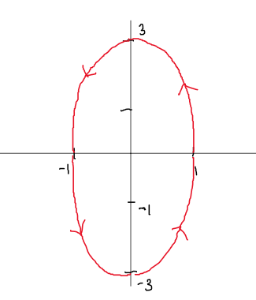

- Sketch a graph of the continuous polar curve whose points satisfy the following criteria.
- As increases from 0 to , r stays constant at -2.
- As increases from to , r increases from -2 to 0.
- As increases from to , r increases from 0 to 2.
- As increases from to , r stays constant at 2.

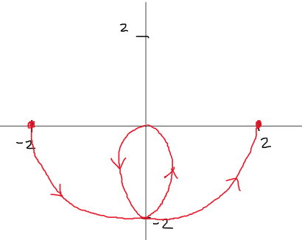

- Sketch a graph of the continuous polar curve whose points satisfy the following criteria.
- As increases from 0 to , r decreases from 2 to 0.
- As increases from to , r decreases from 0 to -2.
- As increases from to , r increases from -2 to 0.
- As increases from to , r increases from 0 to 2.

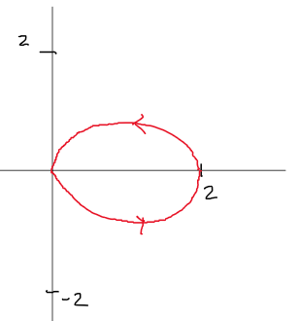

Note that the 3rd and 4th bullet points above could just create a curve that overlaps the curves created by the first two bullet points. This is what is pictured in the image above.

- Sketch a graph of the continuous polar curve whose points satisfy the following criteria.
- At , the curve is at .
- Between , r is always negative and increasing.
- Between , r is always positive and increasing.
- Between , r is always positive and decreasing.
- only when .
- At , the curve is at

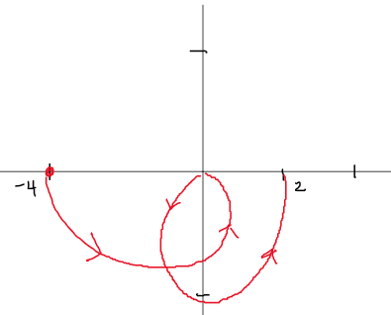

- Convert the polar equation to a Cartesian equation and solve this resulting equation for y.

- Convert the following polar equation to Cartesian coordinates .

- Convert the following rectangular equation to polar coordinates .

- Convert the following polar equation to Cartesian coordinates .

- Convert the following rectangular equation to polar coordinates .

